### Ontology Configurator

In order to manage the ontologies, *Protégé Desktop* (http://protege.stanford.edu/products.php) needs to be installed. Download and installation instructions, as well as tutorials can be found in the Protégé documentation at [*http://protegewiki.stanford.edu/wiki/Protege4GettingStarted*](http://protegewiki.stanford.edu/wiki/Protege4GettingStarted).

Protégé allows to load the ontologies of the middleware and the worlds via their URLs published by the context manager (<http://localhost:8090/eu.osmose.cm.web/services/ContextManagerWebService/ontologies>). Figure 22 shows the user interface of Protégé with the OSMOSE Platform Elements ontology loaded. Users can switch between entities, classes, individuals or object and data properties via the tab bar, or use additional views to query or visualize the loaded ontology. In each of the views, description about selected elements can be found on the right side (usage, annotations, SubClasses, Members etc…). Reasoners can be used via the main toolbar, allowing to investigate inferred knowledge and validate ontology changes. Inferred knowledge is visualized by a light yellow background (see Figure 23).

To give an example, please refer to Figure 24. Each Resource is given a Resource Type by the object property Resource_Type. When, for example, an event is triggered and the Resource that relates to the event is analysed, it can be distinguished between human and computer resources by checking the resource type.

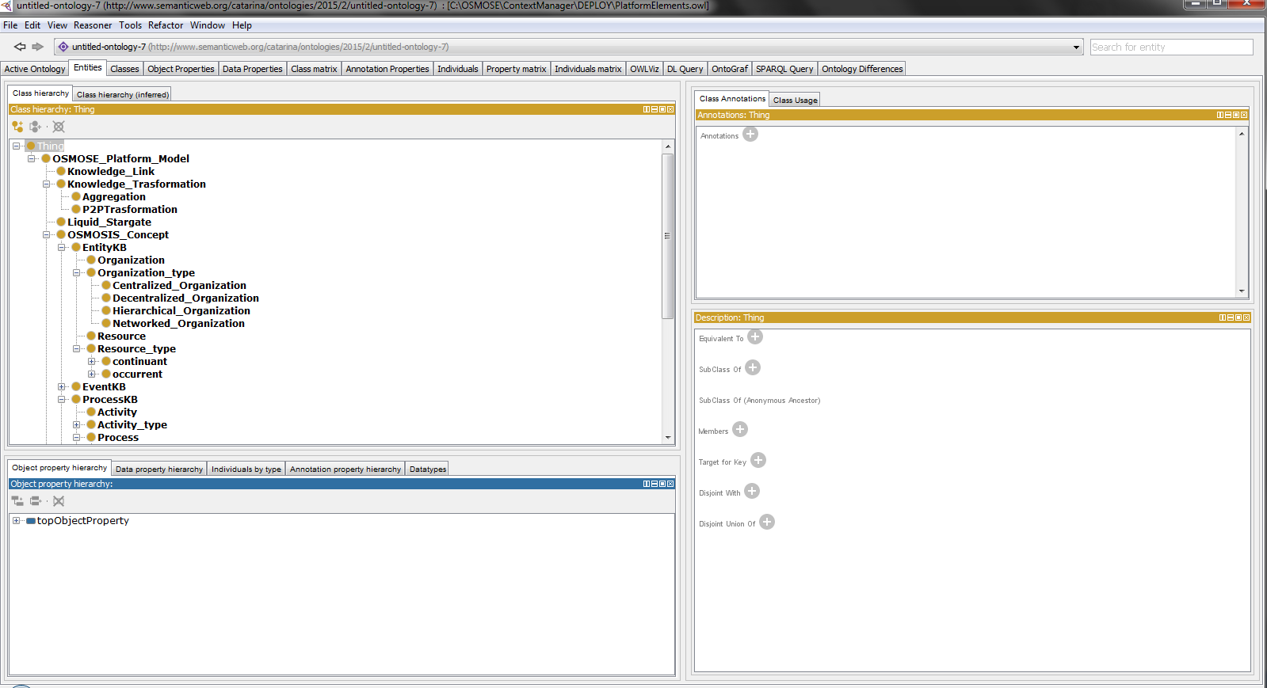

Figure 26 – OSMOSE platform elements in Protégé

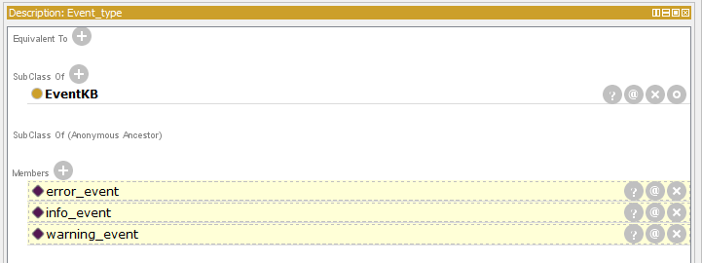

Figure 27 - Protégé inferred knowledge of OSMOSE platform

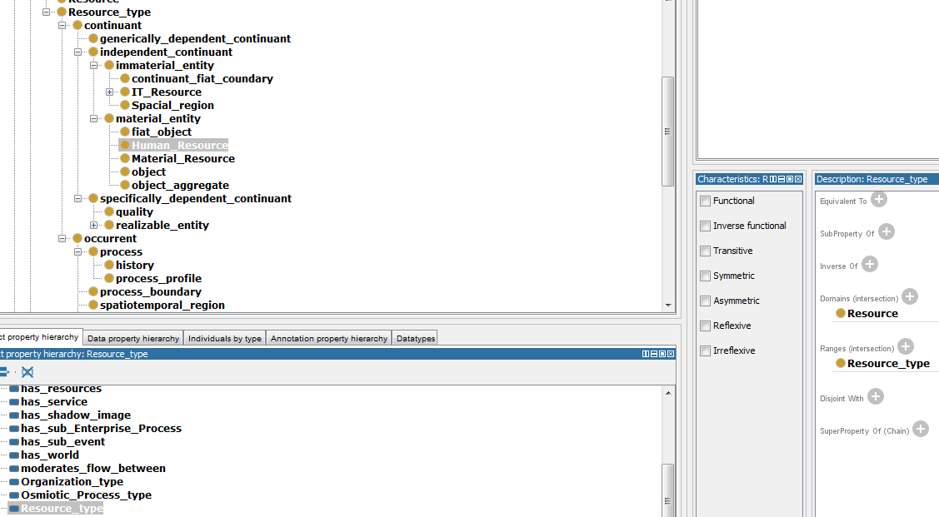

Figure 28 - Protégé Resource Type Example of OSMOSE platform